PCR Guidance-Texts for Building-Related
Products and Services

From the range of Environmental Product Declarations of Institute Construction and Environment e.V. (IBU)
Part B: Requirements on the EPD for
Pumps for liquids and liquids with solids

www.ibu-epd.com

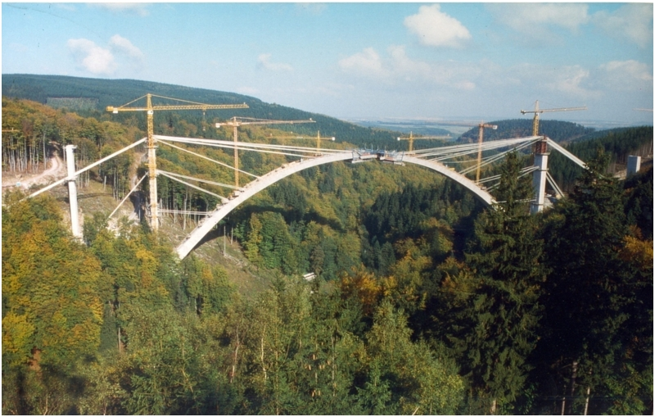

Imprint:
Publisher:
Institut Bauen und Umwelt e.V.
Panoramastr. 1
10178 Berlin
First publication and periodic revisions
Version | Comments | Status
1.0 | Publication of the PCR | 08/2018
Tracking of versions of the PCR Template
Version | Comments | Status
1.0 | Adjustment in chapter 2.1, 2.3 according to the decision of the SVA Nr. 20160715 m+n+o+p | 26.09.2016
1.1 | Implementation of the SVR decisions No. 20170315-e; No. 20170315-j; No. 20170315-k; Nr. 20170315-i | 10.04.2017
1.2 | Implementation of the SVR Decision no. 20171027-i + Decision no. 20161104-j | 30.11.2017
Tracking of versions PCR specific
Version | Comments | Status
© Institut Bauen und Umwelt e.V. Any type of reproduction, including excerpts thereof, is only permitted with the publisher's approval.

Scope
This document contains the Requirements on an Environmental Product Declaration (EPD) for the range of environmental product declarations published by Institut Bauen und Umwelt e.V. (IBU) based on the /EN 15804/ standard. The document applies for:
- Pumps powered by an electrical motor for movement of any type of liquid, including liquids which transport solids

The requirements on the EPD include:
- Requirements on the /EN 15804/ standard as a European core EPD,
- Complementary requirements on IBU EPD

The calculation rules for the life cycle assessment and requirements on the project report are specified in a separate document as Part A of the Product Category Rules.

The general principles for the EPD range of Institut Bauen und Umwelt e.V. (IBU) also apply.
Insert text: Requirements on the content are shown in blue colour under the respective titles. These colored texts can be edited by clicking. In the appearing text editor, the requirements on the content are outlined above for further assistance. The relevant text can be entered below. After confirming the input, texts are incorporated into the document and displayed.
Inserting images: Using the text editor, "broad" and "small" pictures can be added. If you click on the respective button in the editor, you can select the image file and upload it. After uploading, the figure is shown in the text editor and can be changed in size by clicking and pulling the edges.
Technical tables: Click on the table, to open the table editor. Insert your values (= numbers) in the respective field in the column "Value". For each row you can choose between 3 value types: value (= number), range (= consisting of two numbers separated with a hyphen) and a free text (e.g. "test passed after 3 days"). On the far left you can hide rows that are not relevant by clicking on the check. Click the button “add new property” to generate a new row with free text space. It is not allowed to insert a picture instead of a table!
Chapter 5, "Results of the LCA ': click on the first table "system boundaries" and select all life stages you want to declare in the following dialog. Then the following three tables are adjusted according to your entries. Now you can insert numerical values by clicking on the tables. The numerical values are to be indicated with three significant digits. To achieve an optimal representation, the "exponential view" can be selected for each impact indicator.
Storing/saving is done fully automatically.
The first three pages of the document will be deleted automatically after creation of the EPD.
Labeled sample texts are proposals to facilitate the creation of an EPD. If they are accepted into an EPD, they should be checked for their accuracy and if necessary adapted for the specific product.
Requirements on content and format:
The chapters of the EPDs must be described in a compact form and in a factually and technically correct way. Judgmental, comparative, or promotional texts are not permitted unless specifically requested in the PCR or if necessary in the context of the EPD. Each document is carefully checked before publication.
f
Extent of an EPD: For technical reasons an EPD may contain one data set only. This means that the tables for the LCA results are available only once per EPD. All four tables of the LCA results (Chapter 5) must be located entirely on one side.
An EPD should not exceed 8 pages.
Quotations should be indicated with a slash, for example: /EN 15 804/. The literature cited is to be shown completely in the references (Chapter 8).

Product-group-specific LCA calculation rules from PCR part A
The declaration of use stage module B6 (Operational energy use) is mandatory for compliance with this PCR. The module shall at least include the use of electricity necessary to operate the pump during its intended use, applying realistic and plausible scenarios for the actual product being declared.

The general principle for calculation is to derive an average power input based on a defined load profile as shown in Table 1, and then calculate the use of electricity per year by using the annual operating hours. All methods and assumptions used for calculation of the yearly electricity use must be documented in the project report and the parameters described as part of the additional technical information underlying the scenarios (see section 4).

For products covered by a product-specific regulation implementing EU Directive 2009/125/EC, the method for calculating the average power input in these regulations and related standards shall be used.

Table 1 Load profile for calculating average power input

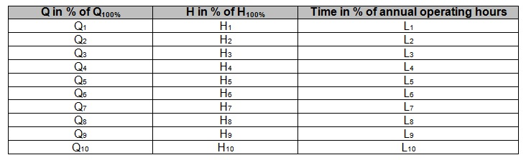

Table 2 EXAMPLE Load profile for HVAC product

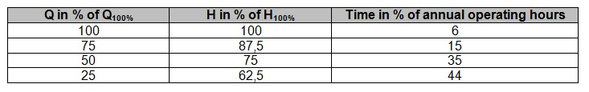

The indicator results in the EPD for module B6 shall be declared per year.

The electricity grid mix used for calculation of the indicator results for module B6 shall be representative for the country or region in which the product is used, and can be either of the following:

- Average Mix EU
- One specific country, if the product is only used in that country
The electricity grid mix used for calculation shall be clearly stated in the EPD together with any relevant assumptions and justifications. It shall also be consistent with any other use stage scenario defined for other modules, if any, as well as the geographical coverage of the EPD in general.

ENVIRONMENTAL PRODUCT DECLARATION
as per /ISO 14025/ and /EN 15804/
Owner of the Declaration
Programme holder | Institut Bauen und Umwelt e.V. (IBU)
Publisher | Institut Bauen und Umwelt e.V. (IBU)
Declaration number
ECO EPD Ref. No.
Issue date
Valid to
www.ibu-epd.com / https://epd-online.com
Name of declared product
Name of manufacturer/association
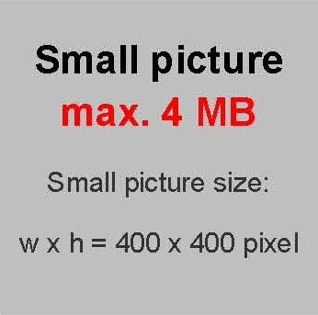
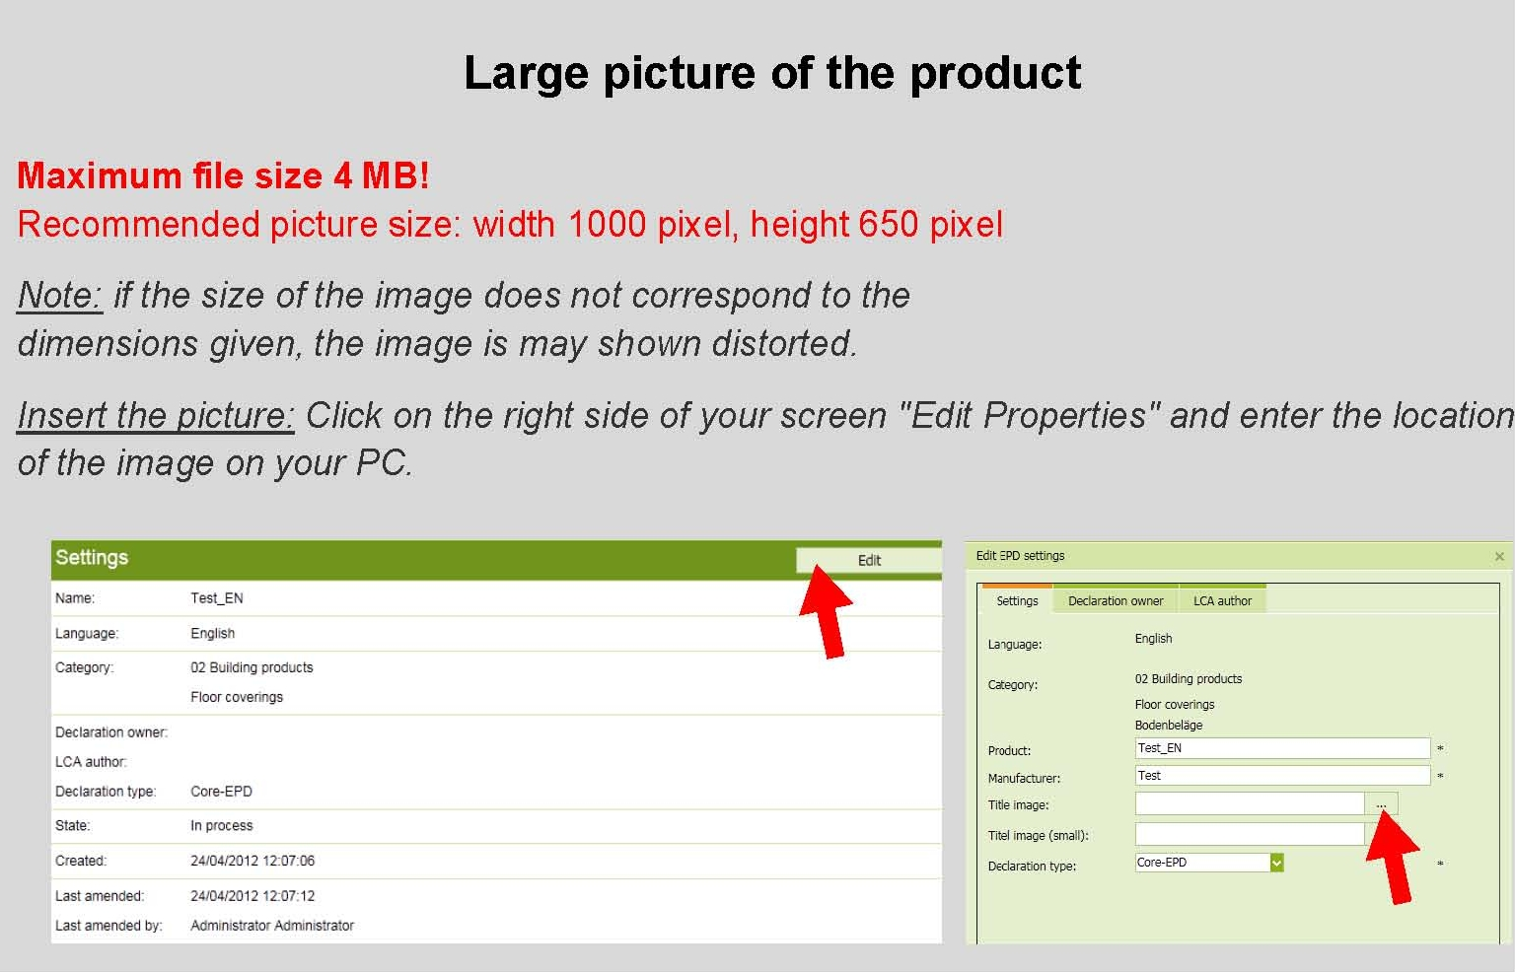

General Information

 | Name of the manufacturer |  | Name of the product
 | Programme holder  IBU - Institut Bauen und Umwelt e.V.  Panoramastr. 1  10178 Berlin  Germany |  | Owner of the declaration  Name of the manufacturer  Street  Postal Code/City
 | Declaration number |  | Declared product / declared unit  Name of declared product / declared unit
 | This declaration is based on the product category rules:  Name of PCR, 08.2018  (PCR checked and approved by the SVR)  Issue date  Valid to |  | Scope:  The products, plants and their locations must be outlined, on which data the Life Cycle Assessment is based and for which the declaration applies.  For average EPDs, e.g. association EPDs, the plants/companies under review on whose data the LCA is based must be named; as an alternative, the representatively of the declaration can be depicted, e.g. for the association, by declaring the production volume covered by the LCA as a percentage of the entire volume of the declared product manufactured by all association members in the year of reference. It shall be clearly mentioned in this clause if the EPD represents an average EPD, e.g. as an association EPD.  The owner of the declaration shall be liable for the underlying information and evidence; the IBU shall not be liable with respect to manufacturer information, life cycle assessment data and evidences.
 |  |  | Verification
 |  |  | The standard /EN 15804/ serves as the core PCR
Independent verification of the declaration and data
according to /ISO 14025:2010/
 | Prof. Dr.-Ing. Horst J. Bossenmayer  (President of Institut Bauen und Umwelt e.V.) |  | internally x externally
 | Hans Peters  (Head of Board IBU) |  | Name of verifier  (Independent verifier appointed by SVR)

Product

Product description / Product definition
The declared products must be described.

In addition to a general product description, the trade names of the products / product groups (including any product codes) must be mentioned to which the EPD applies.
If the declaration of trade names is not meaningfully possible (e.g. in the context of association EPDs), the product description must clearly demarcate the products / product groups to which the EPD applies.
.
EXAMPLE:
The declared product is a circulator pump for circulating clean liquids in heating and cooling applications as well as domestic hot water circulation systems. The pump is a centrifugal pump powered by an electrical motor. The rotor is directly coupled to the impeller and immersed in the pumped medium.

Please select one of the following options:

[Alternative 1a: Product according to the CPR based on a hEN]:
For the placing on the market of the product in the EU/EFTA (with the exception of Switzerland) Regulation (EU) No. 305/2011 (CPR) applies. The product needs a declaration of performance taking into consideration /EN xyz:date/, title and the CE-marking.
For the application and use the respective national provisions apply.

[Alternative 1b: Products according to the CPR based on an ETA].
For the placing of the product on the market in the EU/EFTA (with the exception of Switzerland) the Regulation (EU) No. 305/2011 (CPR) applies. The product needs a declaration of performance taking into consideration /ETA no. xyz/, date, title and the CE-marking.
For the application and use the respective national provisions apply.

[Alternative 2a: Product not harmonised in accordance with the CPR but in accordance with other provisions for harmonisation of the EU]:
For the placing on the market in the EU/EFTA (with the exception of Switzerland) the following legal provisions apply:
- /Directive no. xyz/, date, title
- /Regulation no. xyz/, date, title
- and the harmonised standards based on these provisions:
- /EN xyz:date/, title

The CE-marking takes into account the proof of conformity with the respective harmonized standards based on the legal provisions above.
For the application and use the respective national provisions apply.

[Alternative 2b: Product harmonized as well in accordance with the CPR as with other provisions for harmonisation of the EU]:
For the placing of the product on the market in the EU/EFTA (with the exception of Switzerland) the Regulation (EU) No. 305/2011/ (CPR) and the following other provisions for harmonisation apply:
- /Directive (EU) xyz/, date, title
- /Regulation (EU) no. xyz/, date, title.

The product needs a declaration of performance in accordance with the CPR taking into consideration /EN xyz:date/, title or /ETA no. xyz/, date, title respectively and the CE-marking.
The CE-marking for the product takes into account the Declaration of Performance in accordance with the CPR and the proof of conformity with the following harmonised standards or based on the other provisions for harmonisation:
- /EN xyz:date/, title
- /source/, date, title

For the application and use the respective national provisions apply.

[Alternative 3: Product for which no legal provisions for harmonisation of the EU exist]
For the use and application of the product the respective national provisions at the place of use apply, in Germany for example the building codes of the countries and the corresponding national specifications.

Application
The designated application must be specified for the products covered in the EPD.

Technical Data
The technical specifications of the
products within the scope of the EPD shall be listed, including the reference to the test methods/test standards for each specification.
For products with CE marking, the technical specifications must be specified in accordance with information in the declaration of performance.
Note: Electrical pumps usually falls under the scope of several internal market directives and regulations, such as the Machinery directive, Ecodesign Directive, Radio Equipment Directive etc. The relevant technical data given in the EPD will vary depending on the type of product and areas of application, and the table below should be adjusted accordingly.
Constructional data
Name | Value | Unit
Frequency |  | Hz
Flow range (max) |  | m³/h
Power input Average (from load profile describing use) |  | kW
nominal capacity |  | kW
Voltage |  | V
energy efficiency class |  | -
Pumped liquid (e.g. water) |  | -
Head max. |  | m

(Please select one of the following options):

[Alternative 1a: Product according to the CPR, based on a hEN]:
- performance data of the product in accordance with the declaration of performance with respect to its essential characteristics according to /EN xyz:date/, title.
- voluntary data: /source/, date, title (not part of CE-marking).

[Alternative 1b: Product according to the CPR, based on an ETA]:
- performance data of the product in accordance with the declaration of performance with respect to its essential characteristics according to /ETA no. xyz/, date, title.
- voluntary data: /source/, date, title (not part of CE-marking).

[Alternative 2a: Product not harmonised in accordance with the CPR but in accordance with other provisions for harmonisation of the EU]:
- performance data of the product according to the harmonised standards, based on provisions for harmonization.
- voluntary data: /source/, date, title (not part of CE-marking).

[Alternative 2b: Product harmonized as well in accordance with the CPR as with other legal provisions of the EU]:
- performance data of the product in accordance with the declaration of performance with respect to its essential characteristics according to /EN xyz:date/, title or /ETA no. xyz/, date, title respectively.
- performance data of the product, based on the harmonised standards, in accordance with the other provisions for harmonization.
- Voluntary data: /source/, date, title (not part of CE-marking).

[Alternative 3: Product for which no legal provisions for harmonisation of the EU exist]:
Performance data of the product with respect to its characteristics in accordance with the relevant technical provision (no CE-marking).

Delivery status
The dimensions/quantities must be declared for the products covered in this EPD in their delivery status.

Base materials / Ancillary materials
The main constituents of the product or its components shall be indicated as mass percentages to enable the user of the EPD to understand the composition of the product in delivery status. This information should support safety and efficiency during installation, use and disposal of the product.
When substances from the “Candidate List of Substances of Very High Concern for Authorisation” (SVHC) are part of the formulation with a mass percentage of > 0,1 of the mass of the construction product, i.e. when they were added to the formulation on purpose, then the substances shall be declared including CAS-number.

If the construction product is a substance or mixture under the chemical law (REACH), the concentration limit value refers to the entire product; if it is an article, the partial product or component applies as a unit of reference.
The Candidate list can be found on the ECHA website address: https://echa.europa.eu/de/home.
This declaration must be formulated as follows:
1) “This product/article/at least one partial article contains substances listed in the candidate list (date: dd.mm.yyyy) exceeding 0.1 percentage by mass: yes/no”.
[if yes: List of respective SVHC and their CAS-number]
..

[If yes:] - Information on the concentration and/or concentration range (comparablermation on hazardous properties and if relevant information on the partial article in the case of articles

If the construction product is a substance or mixture under the chemical law (REACH), the safety data sheet shall be made available in the EPD, e.g. by a link. In addition the concentration of the hazardous substance as well as its hazardous properties have to be stated in the EPD.

CMR substances in categories 1A and 1B must also be declared including CAS-number if a European harmonised classification is available as well as information on treatment with biocides.
This statement on other CMR substances which are not listed as SVHC and on biocides must be formulated as follows:

2) “This product/article/at least one partial article contains other CMR substances in categories 1A or 1B which are not on the candidate list, exceeding 0.1 percentage by mass: yes/no”

[If yes:] – List the concentration and/or concentration ranges (comparable to the information on a safety data sheet), provide information on hazardous properties and if relevant information on the partial article in the case of articles.

3) “Biocide products were added to this construction product or it has been treated with biocide products (this then concerns a treated product as defined by the (EU) Ordinance on Biocide Products No. 528/2012): yes/no”

[If yes:] - List the biocides referred to above.
The active substance and the product type (in-can preservative, film preservative, wood protection etc. according to the Ordinance on Biocide Products (see also 1.4) must be indicated.

Ancillary materials and additives remaining on the product must also be declared
If additives such as fire retardants, softeners or biocides are used, their functional chemical group must be indicated.
.

Statements like “…free of ….” and/or “…does not contain…” may not be used.

Manufacture
The manufacturing process must be described and can be illustrated using a simple graphic. If the EPD applies for several locations, the production processes must be described for all sites.

Quality management systems can be referred to.

Environment and health during manufacturing
Presentation of measures relating to health protection during the manufacturing process extending beyond national guidelines (of the production country).

Presentation of measures relating to environmental protection during the manufacturing process extending beyond national guidelines or plant-specific requirements, e.g. description of special environmentally-friendly dealings with waste air, waste water and waste as well as noise emissions.

Information on the Environment Management System or similar (if available).

Product processing/Installation
Description of the type of processing,
machinery and tools used, dust extraction etc., auxiliary materials needed for installation as well as measures for noise reduction.
Information on the rules of technology as well as on workers safety and environmental protection is possible.

Packaging
Information on product-specific packaging
:
- type,
- composition and
- possible reuse, recycling, energy recovery and disposal of packaging materials (paper, pallets, foils etc.).

Condition of use
Information should be provided here regarding changes in material composition over the service life of the product and/or regarding environmentally relevant material inherent properties over the service life of the product.

Environment and health during use
Information on the relationships between the product, the environment and health.

Information on the possible content of harmful substances or emissions.

Note: recommendations concerning cleaning, maintenance, etc. for the declared product should be listed in the corresponding section in 4 “Technical information on scenarios”.

Reference service life
The declaration of the reference service life (RSL) is imperative for EPDs covering the complete use stage (modules B1-B7), or if a use stage scenario is described, which refers to the lifetime of the product. If not all modules of the use stage are declared and no use stage scenario covering the full lifetime of the product is described, then the indication of the RSL (according to /ISO 15686:1, -2, -7 and -8/) is voluntary.

The RSL must refer to the declared technical and functional quality of the product. It must be established in line with all of the specific rules in the European product standards and must also take consideration of the /ISO 15686:1, -2, -7 and -8/ standards.
Where information is available for deriving the RSL from European product standards, such data has priority.
Information on the product’s RSL requires specification of compatible scenarios for the product stage, construction process stage and use stage. The RSL is dependent on the properties of the product and reference in-use conditions. These conditions shall be declared together with the RSL in clause 4 and it shall be stated that the RSL applies for the reference conditions only.

If a reference service life (RSL) cannot be declared according to ISO 15686 (or it is not relevant for consideration of the LCA), this has to be stated clearly in the EPD.

In such cases a service life can be declared in accordance with the BBSR table "Service lives of components for life cycle assessment according to BNB" (http://www.nachhaltigesbauen.de/baustoff-und-gebaeudedaten/nutzungsdauern-von-bauteilen.html).

It shall be unambiguously stated that a service life (not: a reference service life) in accordance with the BBSR table (or based on a manufacturer’s declaration (see below)) is not a RSL according to ISO 15686.

A service life provided by the manufacturer can be declared as an alternative to the value from the BBSR table. This information shall be accompanied by explanations on the origin of the declared service life, e.g. referring to simulations, tests, an assessment of the manufacturer or statistical data, etc. and shall contain the specification of the application for which the stated service life is valid (to be provided in clause 4).

The requisite information for technical building installations should be taken from VDI 20673.

Description on the influences on the ageing of the product when applied in accordance with the rules of technology.

Extraordinary effects

Fire
.
Information on the fire performance according to /EN 13501:1/ or established national standards. According to /EN 13501:1/:
- the classes of building products regarding their fire performance are predefined as: A1, A2, B, C, D, E and F;
- the classes of flaming droplets / particles are pre-defined as: d0, d1 or d2,
the classes for smoke density are pre-defined as: s1, s2, or s3.
Fire protection
Name | Value
Building material class
Burning droplets
Smoke gas development

Water
Information on the product performance including possible impacts on the environment following the unforeseeable influence of water, e.g. flooding.

Mechanical destruction
If relevant: information on the product performance including possible impacts on the environment following unforeseeable mechanical destruction.

Re-use phase
The possibilities of re-use, recycling and energy recovery must be described.

Disposal
The possible disposal channels must be indicated.
The waste code in accordance with the European Waste Index must be described.

Further information
Possible sources of additional information, e.g. homepage, reference source for safety data sheet.

LCA: Calculation rules

Declared Unit
The declared unit, the mass reference and the conversion factor to 1 kg must be indicated in the appropriate table as declared.

If averages are declared across various products, the average breakdown must be explained

The declared unit is 1 piece (pcs.) of product.

Declared unit
Name | Value | Unit
Declared unit |  | pce.
Mass reference |  | kg/pce
Conversion factor to 1 kg |  | -

For IBU core EPDs (where clause 3.6 is part of the EPD): for average EPDs, an estimate of the robustness of the LCA values must be made, e.g. concerning variability of the production process, geographical representatively and the influence of background data and preliminary products compared to the environmental impacts caused by actual production.

System boundary
Type of the EPD: choose as appropriate: cradle to gate, cradle to gate - with options, cradle to grave.

The modules considered in the life cycle assessment as per “system boundaries” outlined in section 5.5. of the PCR, Part A: “Calculation Rules for the Life Cycle Assessment and Requirements on the Project Report” must be described in brief. The description should be product specific; it should be apparent as to what processes are considered in what modules.

Estimates and assumptions
Key assumptions and estimates for interpretation of the life cycle assessment should be listed here, provided that they are not dealt with in other sections of the main clause 3 “LCA: Calculation rules”.

Cut-off criteria
The use of cut-off criteria as per the PCR, Part A: “Calculation Rules for the Life Cycle Assessment and Requirements on the project report” must be documented here.

Background data
The sources for background data in the LCA used must be provided.

Data quality
An estimate should be made as regards data quality (addressing both foreground and background data), whereby the age of background data used must be indicated.

For average EPDs, an estimate of the robustness of the LCA values must be made, e.g. concerning variability of the production process, geographical representatively and the influence of background data and preliminary products compared to the environmental impacts caused by actual production.

Period under review
The period under review for the collection of production data and the resulting averages (if applicable) shall be documented.

Allocation
The allocations of relevance for calculation (appropriation of expenses across various products) must be indicated,
at least:
- allocation of energy, auxiliary and operating materials used for individual products in a factory;
allocation of co-production processes;
- allocation in the use of recycled and/or secondary raw materials;
- loads and benefits beyond the system boundary from recycling or energy recovery of packaging materials and production waste;
- loads and benefits beyond the system boundary from recycling or energy recovery from the end of life of the product

whereby reference must be made to the modules in which the allocations are performed.

Comparability
Basically, a comparison or an evaluation of EPD data is only possible if all the data sets to be compared were created according to /EN 15804/ and the building context, respectively the product-specific characteristics of performance, are taken into account.

The used background database has to be mentioned.

LCA: Scenarios and additional technical information

The following technical scenario information is required for the declared modules and optional for non-declared modules. Modules for which no information is declared can be deleted; additional information can also be listed if necessary.

The following technical information is a basis for the declared modules or can be used for developing specific scenarios in the context of a building assessment if modules are not declared (MND).

If the use of packaging material for the declared product is declared in EPDs in Module A3, but Module A5 is not declared including the disposal of the packaging material on the construction site, the amounts of packaging materials included in the LCA calculations must be declared as technical scenario information for Module A5.
.
Transport from the gate to the site (A4)
Name | Value | Unit
Litres of fuel |  | l/100km
Transport distance |  | km
Capacity utilisation (including empty runs) |  | %
Gross density of products transported |  | kg/m³
Capacity utilisation volume factor |  | -

Assembly (A5)
Name | Value | Unit
Auxiliary |  | kg
Water consumption |  | m³
Other resources |  | kg
Electricity consumption |  | kWh
Other energy carriers |  | MJ
Material loss |  | kg
Output substances following waste treatment on site |  | kg
Dust in the air |  | kg
VOC in the air |  | kg

Use or application of the installed product (B1) see section 2.12 "Use"
Name | Value | Unit

Maintenance (B2)
Name | Value | Unit
Information on maintenance |  | -
Maintenance cycle |  | Number/RSL
Water consumption |  | m³
Auxiliary |  | kg
Other resources |  | kg
Electricity consumption |  | kWh
Other energy carriers |  | MJ
Material loss |  | kg

Repair (B3)
Name | Value | Unit
Information on the repair process |  | -
Information on the inspection process |  | -
Repair cycle |  | Number/RSL
Water consumption |  | m³
Auxiliary |  | kg
Other resources |  | kg
Electricity consumption |  | kWh
Other energy carriers |  | MJ
Material loss |  | kg

Replacement (B4) / Refurbishment (B5)
Name | Value | Unit
Replacement cycle |  | Number/RSL
Electricity consumption |  | kWh
Litres of fuel |  | l/100km
Replacement of worn parts |  | kg

In case a reference service life according to applicable ISO standards is declared then the assumptions and in-use conditions underlying the determined RSL shall be declared. In addition, it shall be stated that the RSL applies for the reference conditions only

The same holds for a service life declared by the manufacturer. Corresponding information related to in-use conditions needs not be provided if a service life taken from the list on service life by /BNB/ is declared.
Reference service life
Name | Value | Unit
Reference service life (according to ISO 15686-1, -2, -7 and -8) |  | a
Life Span (according to BBSR) |  | a
Life Span according to the manufacturer |  | a
Declared product properties (at the gate) and finishes |  | -
Design application parameters (if instructed by the manufacturer), including the references to the appropriate practices and application codes |  | -
An assumed quality of work, when installed in accordance with the manufacturer’s instructions |  | -
Outdoor environment, (for outdoor applications), e.g. weathering, pollutants, UV and wind exposure, building orientation, shading, temperature |  | -
Indoor environment (for indoor applications), e.g. temperature, moisture, chemical exposure |  | -
Usage conditions, e.g. frequency of use, mechanical exposure |  | -
Maintenance e.g. required frequency, type and quality and replacement of components |  | -

Operational energy use (B6) and Operational water use (B7)
Name | Value | Unit
Water consumption |  | m³
Electricity consumption |  | kWh
Other energy carriers |  | MJ
Equipment output |  | kW

End of life (C1-C4)
Name | Value | Unit
Collected separately waste type |  | kg
Collected as mixed construction waste |  | kg
Reuse |  | kg
Recycling |  | kg
Energy recovery |  | kg
Landfilling |  | kg

Reuse, recovery and/or recycling potentials (D), relevant scenario information
Name | Value | Unit

LCA: Results
In Table 1 "Description of the system boundary", all declared modules shall be indicated with an "X"; all modules that are not declared shall be indicated with "MND" (As default the modules B3, B4, B5 are marked as MNR – module not relevant).In the following tables, columns can be deleted for modules that are not declared. Indicator values should be declared with three valid digits (eventually using exponential form (e.g. 1,23E-5 = 0,0000123). A uniform format should be used for all values of one indicator. If several modules are not declared and therefore have been deleted from the table, the abbreviations for the indicators can be replaced by the complete names, while the readability and clear arrangement should be maintained; the legends can then be deleted.
If due to relevant data gaps, an indicator cannot be declared in a robust way, then the abbreviation “IND” (indicator not declared) should be used for this indicator. If no reference service life is declared (see chapter 2.13 "Reference Service Life"), the LCA results of the modules B1-B2 and B6-B7 shall refer to a period of one year. This shall then be indicated as an explanatory text below the tables. In addition, the formula for the quantification of such B-modules over the total life cycle shall be provided.
DESCRIPTION OF THE SYSTEM BOUNDARY (X = INCLUDED IN LCA; MND = MODULE NOT DECLARED)
PRODUCT STAGE |  |  | CONSTRUCTION PROCESS  STAGE |  | USE STAGE |  |  |  |  |  |  | END OF LIFE STAGE |  |  |  | BENEFITS AND LOADS BEYOND THE SYSTEM BOUNDARIES
Raw material supply | Transport | Manufacturing | Transport from the gate to the site | Assembly | Use | Maintenance | Repair | Replacement | Refurbishment | Operational energy use | Operational water use | De-construction  demolition | Transport | Waste processing | Disposal | Reuse-  Recovery-  Recycling-  potential
A1 | A2 | A3 | A4 | A5 | B1 | B2 | B3 | B4 | B5 | B6 | B7 | C1 | C2 | C3 | C4 | D

RESULTS OF THE LCA - ENVIRONMENTAL IMPACT: declared unit and product
Parameter | Parameter | Unit
GWP | Global warming potential | [kg CO₂-Eq.]
ODP | Depletion potential of the stratospheric ozone layer | [kg CFC11-Eq.]
AP | Acidification potential of land and water | [kg SO₂-Eq.]
EP | Eutrophication potential | [kg (PO₄)³⁻-Eq.]
POCP | Formation potential of tropospheric ozone photochemical oxidants | [kg ethene-Eq.]
ADPE | Abiotic depletion potential for non-fossil resources | [kg Sb-Eq.]
ADPF | Abiotic depletion potential for fossil resources | [MJ]

Caption | GWP = Global warming potential; ODP = Depletion potential of the stratospheric ozone layer; AP = Acidification potential of land and water; EP = Eutrophication potential; POCP = Formation potential of tropospheric ozone photochemical oxidants; ADPE = Abiotic depletion potential for non-fossil resources; ADPF = Abiotic depletion potential for fossil resources

RESULTS OF THE LCA - RESOURCE USE: declared unit and product
Parameter | Parameter | Unit
PERE | Renewable primary energy as energy carrier | [MJ]
PERM | Renewable primary energy resources as material utilization | [MJ]
PERT | Total use of renewable primary energy resources | [MJ]
PENRE | Non-renewable primary energy as energy carrier | [MJ]
PENRM | Non-renewable primary energy as material utilization | [MJ]
PENRT | Total use of non-renewable primary energy resources | [MJ]
SM | Use of secondary material | [kg]
RSF | Use of renewable secondary fuels | [MJ]
NRSF | Use of non-renewable secondary fuels | [MJ]
FW | Use of net fresh water | [m³]

Caption | PERE = Use of renewable primary energy excluding renewable primary energy resources used as raw materials; PERM = Use of renewable primary energy resources used as raw materials; PERT = Total use of renewable primary energy resources; PENRE = Use of non-renewable primary energy excluding non-renewable primary energy resources used as raw materials; PENRM = Use of non-renewable primary energy resources used as raw materials; PENRT = Total use of non-renewable primary energy resources; SM = Use of secondary material; RSF = Use of renewable secondary fuels; NRSF = Use of non-renewable secondary fuels; FW = Use of net fresh water

RESULTS OF THE LCA – OUTPUT FLOWS AND WASTE CATEGORIES:
declared unit and product
Parameter | Parameter | Unit
HWD | Hazardous waste disposed | [kg]
NHWD | Non-hazardous waste disposed | [kg]
RWD | Radioactive waste disposed | [kg]
CRU | Components for re-use | [kg]
MFR | Materials for recycling | [kg]
MER | Materials for energy recovery | [kg]
EEE | Exported electrical energy | [MJ]
EET | Exported thermal energy | [MJ]

Caption | HWD = Hazardous waste disposed; NHWD = Non-hazardous waste disposed; RWD = Radioactive waste disposed; CRU = Components for re-use; MFR = Materials for recycling; MER = Materials for energy recovery; EEE = Exported electrical energy; EEE = Exported thermal energy

LCA: Interpretation

To facilitate comprehension of the life cycle assessment, both the relevant indicators of the life cycle inventory and the indicators of the impact assessment declared in section 5 “LCA results” have to be interpreted in a dominance analysis.
An illustration of the results with figures is recommended, e.g. for the dominance analysis, the distribution of impacts across the modules, the CO₂-balance, etc. as appropriate for a reader to understand the environmental profile of the declared product.
The interpretation shall also include a description of the time frame and/or variability of the LCIA results (in qualitative or quantitative terms) if the EPD is valid for several products or producers.

Requisite evidence

As a general rule, all statements must be documented with measured data (presented by the corresponding test certificatesThe methods of evidence and the test conditions have to be described together with the results.

If substances are not detected, the limit of detection must be included in the declaration.

Interpreting statements such as “… free of …” or “… are entirely harmless …” are not allowed.

If an evidence required by the specific PCR part B is not provided, this has to be justified under the respective title for the required evidence.

If relevant for the scope of application of the declared product, or if derivable from its material composition, it is recommended to provide additional adequate evidence.
Not relevant

References
The literature referred to in the Environmental Product Declaration must be listed in full.

Standards already fully quoted in the EPD do not need to be listed here again.
The current version of PCR Part A and PCR Part B of the PCR document on which they are based must be referenced
.
/IBU 2016/
IBU (2016): General Programme Instructions for the Preparation of EPDs at the Institut Bauen und Umwelt e.V., Version 1.1 Institut Bauen und Umwelt e.V., Berlin.
www.ibu-epd.de

/ISO 14025/
DIN EN /ISO 14025:2011-10/, Environmental labels and declarations — Type III environmental declarations — Principles and procedures

/EN 15804/
/EN 15804:2012-04+A1 2013/, Sustainability of construction works — Environmental Product Declarations — Core rules for the product category of construction products

 | Publisher  Institut Bauen und Umwelt e.V.  Panoramastr. 1  10178 Berlin  Germany | Tel +49 (0)30 3087748- 0  Fax +49 (0)30 3087748- 29  Mail info@ibu-epd.com  Web www.ibu-epd.com
 | Programme holder  Institut Bauen und Umwelt e.V.  Panoramastr 1  10178 Berlin  Germany | Tel +49 (0)30 - 3087748- 0  Fax +49 (0)30 – 3087748 - 29  Mail info@ibu-epd.com  Web www.ibu-epd.com
 | Author of the Life Cycle Assessment  Name  Straße, Nr.  PLZ, Ort  Land  Name  Straße, Nr.  PLZ, Ort  Land | Tel Nummer  Fax Nummer  Mail e-mail  Web Web-Adresse  Tel Nummer  Fax Nummer  Mail e-mail  Web Web-Adresse
 | Owner of the Declaration  Name  Straße, Nr.  PLZ, Ort  Land  Name  Straße, Nr.  PLZ, Ort  Land  Name  Straße, Nr.  PLZ, Ort  Land  Name  Straße, Nr.  PLZ, Ort  Land  Name  Straße, Nr.  PLZ, Ort  Land | Tel Nummer  Fax Nummer  Mail e-mail  Web Web-Adresse  Tel Nummer  Fax Nummer  Mail e-mail  Web Web-Adresse  Tel Nummer  Fax Nummer  Mail e-mail  Web Web-Adresse  Tel Nummer  Fax Nummer  Mail e-mail  Web Web-Adresse  Tel Nummer  Fax Nummer  Mail e-mail  Web Web-Adresse

Additional contents for the transmission of the EPD data set to the ÖKOBAUDAT system
A: Technology description and included processes
Description of the manufacturing process and specification of the processes and materials used.

