PCR Guidance-Texts for Building-Related
Products and Services

From the range of Environmental Product Declarations of Institute Construction and Environment e.V. (IBU)
Part B: Requirements on the EPD for
ETFE construction element

www.ibu-epd.com

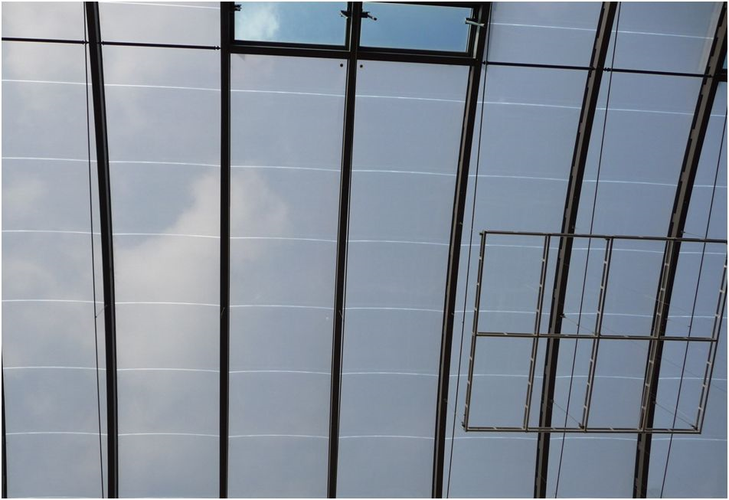

Imprint:
Publisher:
Institut Bauen und Umwelt e.V.
Panoramastr. 1
10178 Berlin
First publication and periodic revisions
Version | Comments | Status
1.0 | First transmission of the PCRs into the database. Layout optimized. Specific data for electronic data exchange completed. | 08.2013
Tracking of versions of the PCR Template
Version | Comments | Status
1.0 | Revision according to the decisions of the SVA from the 22.03.2013. | 05.04.2013
1.1 | Adjustment address IBU | 09.07.2013
1.2 | Insert Signature Managing Director | 15.10.2013
1.3 | Revision according to the decisions of the SVA | 04.07.2014
1.4 | Adjustment in chapter 2.1, 2.3 according to the decision of the SVA Nr. 20160715 m+n+o+p | 26.09.2016
1.5 | Implementation of the SVR decisions No. 20170315-e; No. 20170315-j; No. 20170315-k; Nr. 20170315-i | 10.04.2017
1.6 | Implementation of the SVR Decision no. 20171027-i + Decision no. 20161104-j | 30.11.2017
Tracking of versions PCR specific
Version | Comments | Status
1.0 | Additional product-group-specific LCA calculation rules from PCR part A implemented. | 11.04.2013
1.1 | Extension of the scope | 09.07.2013
© Institut Bauen und Umwelt e.V. Any type of reproduction, including excerpts thereof, is only permitted with the publisher's approval.

Scope
This document contains the Requirements on an Environmental Product Declaration (EPD) from the range of Environmental Product Declarations published by Institut Bauen und Umwelt e.V. (IBU) based on the /EN 15804/ standard. The document applies for:
Construction elements made of ethylene tetrafluorethylene (ETFE) and membranes made of ethylene tetrafluorethylene (ETFE).

The requirements on the EPD include:
- Requirements on the /EN 15804/ standard as a European core EPD,
- Complementary requirements on IBU EPD
The calculation rules for the Life Cycle Assessment and Requirements on the Background Report are specified in a separate document as Part A of the Product Category Rules.
The general principles for the EPD range of Institut Bauen und Umwelt e.V. (IBU) also apply.

Notes on use of the format template
Insert text: Content requirements are shown in blue color under the respective titles. These colored texts can be edited by clicking. In the appearing text editor, the content requirements are outlined above for further assistance. The relevant text can be entered below. After confirming the input, texts are incorporated into the document and displayed.
Inserting images: Using the text editor "broad" and "small" pictures may be added. If you click on the respective button in the editor you can select the image file and upload it. After loading, the figure is shown in the text editor and can be changed in size by clicking and pulling the edges.
Technical tables: Click on the table, to open the table editor. Insert your values (= numbers) in the respective field in the column "Value". For each row you can choose between 3 value types: value (= number), range (= consisting of two numbers separated with a hyphen) and a free text (eg "test passed after 3 days"). On the far left you can hide not relevant rows by clicking on the check. Click the button “add new property” to generate a new row with free text space. It is not allowed to insert a picture instead of a table!
Chapter 5, "Results of the LCA ': click on the first table "system boundaries" and select in the following dialog all life stages you want to declare. Then the following three tables are adjusted according to your entries. Now you can insert numerical values by clicking on the tables. The numerical values are to be indicated with three significant digits. To achieve an optimal representation may be the "exponential view" can be selected depending on impact indicator.
Storing is done fully automatic.
The first three pages of the document will be deleted automatically after creation of the EPD.
Labeled sample texts are proposals to facilitate the creation of an EPD. If they are accepted into an EPD, they should be checked for their accuracy and if necessary adapted product-specific.
Requirements on content and format:
The chapters of the EPDs must be described in a compact form, as well as factually and technically 100% correct. Judgmental, comparative, or promotional texts are not permitted unless specifically requested in the PCR or if necessary in the context of the EPD. Each document is carefully checked before publication.
Extent of an EPD: An EPD may contain due to technical reasons, a maximum of one data set. This means that the tables for the LCA results are available only once per EPD. All four tables of the LCA results (Chapter 5) must be located entirely on one side.
An EPD should not exceed 8 pages.
Quotations should be indicated with a slash, for example: /EN 15 804/. The literature cited is to be shown completely in the references (Chapter 8).

Product-group-specific LCA calculation rules from PCR part A
No product-group-specific LCA calculation rules existing.

ENVIRONMENTAL PRODUCT DECLARATION
as per /ISO 14025/ and /EN 15804/
Owner of the Declaration
Programme holder | Institut Bauen und Umwelt e.V. (IBU)
Publisher | Institut Bauen und Umwelt e.V. (IBU)
Declaration number
ECO EPD Ref. No.
Issue date
Valid to
www.ibu-epd.com / https://epd-online.com
Name of declared product
Name of manufacturer/association
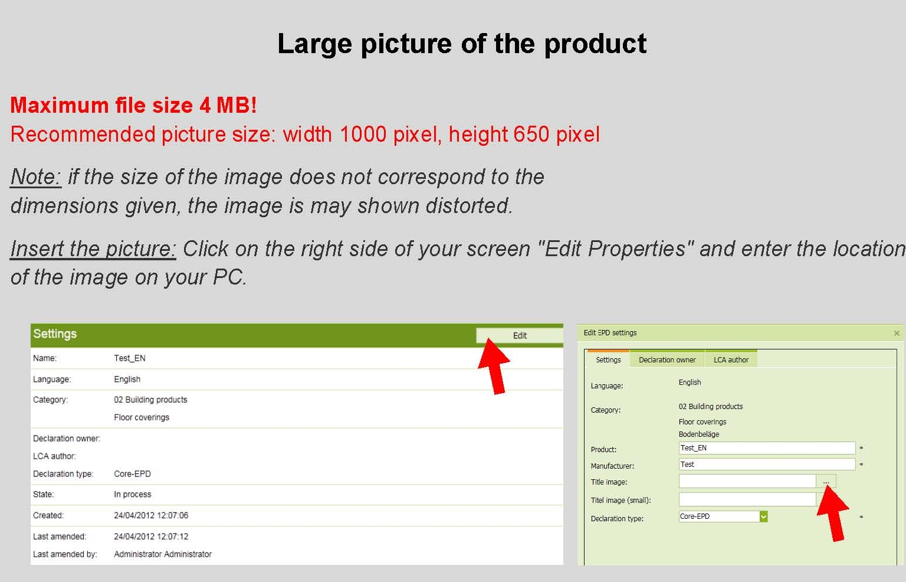

General Information

 | Name of the manufacturer |  | Name of the product
 | Programme holder  IBU - Institut Bauen und Umwelt e.V.  Panoramastr. 1  10178 Berlin  Germany |  | Owner of the Declaration  Name of the manufacturer  Street  Postal Code/City
 | Declaration number |  | Declared product / Declared unit  Name of declared product / declared unit
 | This Declaration is based on the Product Category Rules:  Name of PCR, 07.2014  (PCR tested and approved by the SVR)  Issue date  Valid to |  | Scope:  The products, plants and their locations on which data the Life Cycle Assessment is based and for which the Declaration applies must be outlined.  For average EPDs, an estimate of the robustness of the LCA values must be made, e.g. concerning variability of the production process, geographical representatively and the influence of background data and preliminary products compared to the environmental impacts caused by actual production.  For average EPDs, e.g. association EPDs, the plants/companies under review on whose data the LCA is based must be named; as an alternative, the representatively of the declaration can be depicted, e.g. for the association, by declaring the production volume covered by the LCA as a percentage of the entire volume of the declared product manufactured by all association members in the year of reference.  The owner of the declaration shall be liable for the underlying information and evidence; the IBU shall not be liable with respect to manufacturer information, life cycle assessment data and evidences.
 |  |  | Verification
 |  |  | The CEN Norm /EN 15804/ serves as the core PCR
Independent verification of the declaration
according to /ISO 14025/
 | Prof. Dr.-Ing. Horst J. Bossenmayer  (President of Institut Bauen und Umwelt e.V.) |  | internally x externally
 | Dr.-Ing. Burkhart Lehmann  (Managing Director IBU) |  | Name of verifier  (Independent verifier appointed by SVR)

Product

Product description / Product definition
The declared products must be described.
In addition to a general product description, the trade names of the products / product groups (including any product codes) to which the EPD applies must be mentioned.
If the mention of trade names is e.g. In the context of association EPDs not meaningfully possible, the product description must clearly demarcate the products / product groups to which the EPD applies.
.

Example: three-layered foil cushions
The ABC system is based on the following principle:
Pneumatic stabilised foil elements are combined with a substructure in high-quality aluminium frame systems. Depending on the structural, static or design requirements and specifications, the systems can be formed from 2 to 5 layers of ETFE foil. The number of layers used as well as the type of coating are used to specify the U-values and g-values of the ABC system. Depending on static and constructive requirements, the ETFE foil strengths vary between 100 μm and 300 μm. The individual layers are welded together at the edge and stabilised at approx. 220 Pa (220 N/m²) via a low-pressure system.
This EPD is based on a typical 3-layer system with the following structure:
Bottom film: 200 µm
Middle film: 100 µm
Top film: 200 µm.
Product definition (Please select one of the following options):
/Alternative 1a: Product according to the CPR based on a hEN/:
For the placing on the market of the product in the EU/EFTA (with the exception of Switzerland) Regulation (EU) No. 305/2011 (CPR) applies. The product needs a Declaration of Performance taking into consideration /EN xyz,date, title/ and the CE-marking.
For the application and use the respective national provisions apply.

/Alternative 1b: Products according to the CPR based on an ETA/.
For the placing of the product on the market in the EU/EFTA (with the exception of Switzerland) the Regulation (EU) No. 305/2011 (CPR) applies. The product needs a Declaration of Performance taking into consideration /ETA.xyz,date, title/ and the CE-marking.
For the application and use the respective national provisions apply.

/Alternative 2a: Product not harmonised in accordance with the CPR but in accordance with other harmonisation provisions of the EU/:
For the placing on the market in the EU/EFTA (with the exception of Switzerland) the following legal provisions apply:
/Directive No. xyz, date, title /
/Regulation No.xyz, date, title/
and the harmonised norms based on these provisions:.
/EN xyz, date, title/
The CE-marking takes into account the proof of conformity with the respective harmonized norms based on the legal provisions above.
For the application and use the respective national provisions apply.

/Alternative 2b: Product harmonized as well in accordance with the CPR as with other harmonisation provisions of the EU/:
For the placing of the product on the market in the EU/EFTA (with the exception of Switzerland) the Regulation (EU) No. 305/2011/ (CPR) and the following other harmonisation provisions apply:
/Directive (EU) xyz, date, titel/ or /Regulation (EU) No. xyz, date, title/ respectively. The product needs a Declaration of Performance in accordance with the CPR taking into consideration /EN xyz: date, title/ or /ETA No. xyz , date, title/ respectively, and the CE-marking.
The CE-marking for the product takes into account the Declaration of Performance in accordance with the CPR and the proof of conformity with the following harmonised norms based on the other harmonisation provisions.
/EN…../
For the application and use the respective national provisions apply.

/Alternative 3: Product for which no legal harmonization provisions of the EU exist/
For the use and application of the product the respective national provisions at the place of use apply, in Germany for example the Building Codes of the countries and the corresponding national specifications.

Application
The designated application for the products referred to must be specified

Technical Data
The technical specifications of the products that are within the scope of the EPD are to name with reference to the individual assessment rules (for example, standards).
For products with CE marking, in particular the performances must be specified in accordance with the performance declaration.
Constructional data
Name | Value | Unit
Melting range acc. to ASTM D 4591-07 |  | °C
Grammage (ETFE-foil) |  | kg/m²
Tensile strength acc. to DIN EN ISO 527-1 (ETFE-foil) |  | N/mm²
Tensile stress at 10% strain acc. to DIN EN ISO 527-1 (ETFE-foil) |  | N/mm²
Tensile stress at break acc. to DIN EN ISO 527-1 (ETFE-foil) |  | %
Tear Resistance acc. to DIN 53363 (ETFE-foil) |  | N/mm
Weld strength acc. to DIN 527-1 (ETFE-foil) |  | N/mm²
Total energy transmittance acc. to ISO 15099 (Multiple-layer foil cushion) |  | %
Weathering resistance acc. to ISO 4892-1 (Multiple-layer foil cushion) |  | -

(Please select one of the following options):
/Alternative 1a:Product according to the CPR, based on a hEN/:
• Performance data of the product in accordance with the Declaration of Performance with respect to its Essential Characteristics according to /EN xyz date, title/
• Voluntary data: /source, date, title/ ((Not part of CE-marking)).

/Alternative 1b: Product according tot he CPR, based on an ETA /:
• Performance data of the product in accordance with the Declaration of Performance with respect to its Essential Characteristics according to /ETA xyz No., date, title/
• Voluntary data: /source, date, title/ ((Not part of CE-marking)).

/Alternative 2a: Product not harmonised in accordance with the CPR but in accordance with other harmonisation provisions of the EU/:
• Performance data of the product according to the harmonised norms, based on the harmonisation provisions.
• Voluntary data: /source, date, title/ ((Not part of CE-marking)).

/Alternative 2b : Product harmonized as well in accordance with the CPR as with other legal provisions of the EU/:
• Performance data of the product in accordance with the Declaration of Performance with respect to its Essential Chacteristics according to /EN xyz, date,, title/ or /ETA xyz, No., date, title/ respectively.
• Performance data of the product, based on the harmonised norms, in accordance with the other lharmonisation provisions
• Voluntary data: /source, date, title/ ((Not part of CE-marking)).

/Alternative 3: Product for which no legal harmonization provisions of the EU exist/:
Performance data of the product with respect to its characteristics in accordance with the relevant technical provision ((No CE-marking)).

Delivery status
The dimensions/quantities of products declared must be indicated in the delivery status.

Base materials / Ancillary materials
The primary product components and/or materials must be indicated as a percentage mass to enable the user of the EPD to understand the composition of the product in delivery status. The primary product components and/or substances must be indicated as a percentage by mass enabling the EPD user to understand the composition of the product on delivery. These details should also support safety and efficiency during installation as well as use and disposal of the product.
The declaration of the material product content must at least include a statement concerning the substances contained in the product which are listed in the “Candidate List of Substances of Very High Concern for Authorisation” (SVHC), whereby the last amendment date of the candidate list must be indicated to which the declaration refers.
If the construction product is a substance or mixture under chemical law, the concentration limit value refers to the entire product; if it is a product, the partial product applies as a unit of reference. Insofar as the construction product is a mixture, the safety data sheet must be made available with the EPD (e.g. as a reference) and any SVHC and their concentrations must be indicated in the EPD.
This declaration must be formulated as follows:
“Contains substances on the candidate list (date: dd.mm.yyyy) exceeding 0.1 percentage by mass in at least one partial product: yes/no”
[If yes:] - Information on the concentration and/or concentration range (analogue to the information on a safety data sheet), information on hazardous properties and poss. information on the partial product in the case of products..
CMR substances in categories 1A and 1B must also be indicated if a European harmonised classification is available as well as information on treatment with biocides.
This statement on other CMR substances which are not listed as SVHC and biocides must be formulated as follows:
“Contains other CMR substances in categories 1A or 1B which are not on the candidate list, exceeding 0.1 percentage by mass in at least one partial product: yes/no”
[If yes:] - Information on the concentration and/or concentration range (analogue to the information on a safety data sheet), information on hazardous properties and poss. information on the partial product in the case of products
“Biocide products were added to this construction product or it has been treated with biocide products (this then concerns a treated product as defined by the (EU) Ordinance on Biocide Products No. 528/2012): yes/no”
[If yes:] - List of the SVHC, other CMR substances, biocides referred to above
[If yes:] - The active substance and the product type (in-can preservative, film preservative, wood protection etc. according to the Ordinance on Biocide Products (see also 1.4) must be indicated.
Ancillary materials and additives remaining on the product must also be declared.
If additives such as fire retardants, softeners or biocides are used, their functional chemical group must be indicated.

Manufacture
The manufacturing process must be described and can be illustrated using a simple graphic. If the EPD applies for several locations, the production processes for all locations must be described.
Quality management systems can be referred to.

Environment and health during manufacturing
Presentation of measures relating to health protection during the manufacturing process extending beyond national guidelines (of the production country).
Presentation of measures relating to environmental protection during the manufacturing process extending beyond national guidelines or plant-specific requirements, e.g. description of special environmentally-friendly dealings with waste air, waste water and waste as well as noise emissions.
Information on the Environment Management System or similar (if available).

Product processing/Installation
Description of the type of processing, machinery, tools, dust extraction etc. to be used and auxiliary materials as well as measures for reducing noise
Information on the rules of technology and industrial and environmental protection is possible.

Packaging
Information on product-specific packaging: type, composition and possible reuse of packaging materials (paper, pallets, foils etc.).

Condition of use
Information should be provided here as regards the special features of contents for the period of use.

Environment and health during use
Information on the relationships between products, the environment and health; possible content of harmful substances or emissions.
Any recommendations concerning cleaning, maintenance etc. of the declared product should be listed in the corresponding section in 4 “Technical information on scenarios”.

Reference service life
The indication of the reference service life (RSL) is imperative for EPDs covering the complete use stage (modules B1-B7), or if a use stage scenario is described, which refers to the lifetime of the product. If not all modules of the use stage are being declared, and no use stage scenario which refers to the lifetime of the product is being described, the indication of the RSL (according to /ISO 15686:1, -2, -7 and -8/) is voluntary.
The RSL must refer to the declared technical and functional quality of the product. It must be established in line with all of the specific rules in the European product standards and must also take consideration of the /ISO 15686:1, -2, -7 and -8/ standards.
Where information is available for deriving the RSL from European product standards, such data has priority.

The assumptions on which determination of the reference service life is based and for which the reference service life exclusively applies are provided in section “LCA: Scenarios and additional technical information”. If no RSL in accordance with /ISO 15686/ has been declared, the assumptions for the life time have to be described.
Influences on ageing when applied in accordance with the rules of technology
.

Extraordinary effects

Fire
.Information on fire performance according to /EN 13501:1/ or established national standards. According to /EN 13501/ - the classification of building products is set to A1, A2, B, C, D, E and F; flaming droplets / particles is set to d0, d1 or d2, and the smoke density is set to s1, s2, or s3.
Fire protection
Name | Value
Building material class
Burning droplets
Smoke gas development

Water
Information on product performance including possible impacts on the environment following unforeseeable influence of water, e.g. flooding.

Mechanical destruction
If relevant: Information on product performance including possible impacts on the environment following unforeseeable mechanical destruction.

Re-use phase
The possibilities of re-use, recycling and energy recovery must be described.

Disposal
The possible disposal channels must be indicated.
The waste code in accordance with the European Waste Index must be indicated.

Further information
Optional details, indication of reference source for additional information, e.g. homepage, reference source for safety data sheet.

LCA: Calculation rules

Declared Unit
The declared unit, the mass reference and the conversion factor to 1 kg must be indicated in the appropriate table as declared. If averages are declared across various products, the average breakdown must be explained
The declared unit is 1 m². Other declared units are permissible if conversion to 1 m² is depicted in a transparent manner. The ground reference must be indicated.
Declared unit
Name | Value | Unit
Declared unit |  | m²
Conversion factor to 1 kg |  | -

System boundary
Type of the EPD: choose as appropriate: cradle to gate, cradle to gate - with options, cradle to grave].
The modules considered in the Life Cycle Assessment as per “System limits” outlined in section 5.5. of the PCR, Part A: “Calculation Rules for the Life Cycle Assessment and Requirements on the Background Report” must be described in brief. It should be apparent as to what processes are considered in what modules.

Estimates and assumptions
Key assumptions and estimates for interpretation of the Life Cycle Assessment should be referred to here provided that they are not dealt with in other sections of 3 “LCA: Calculation rules”.

Cut-off criteria
The use of cut-off criteria as per the PCR, Part A: “Calculation Rules for the Life Cycle Assessment and Requirements on the Background Report” must be documented here.

Background data
The sources for background data used must be provided.

Data quality
An estimate should be made as regards data quality (Foreground and Background data), whereby the age of background data used must be indicated.

Period under review
The period under review and ensuing averages must be documented.

Allocation
The allocations of relevance for calculation (appropriation of expenses across various products) must be indicated, at least:
- Allocation in the use of recycled and/or secondary raw materials
- Allocation of energy, auxiliary and operating materials used for individual products in a factory
- Credits from recycling or energy recovery of packaging materials and production waste
- Credits from recycling or energy recovery from the end of life of the product

whereby reference must be made to the modules in which the allocations are performed.

Comparability
Basically, a comparison or an evaluation of EPD data is only possible if all the data sets to be compared were created according to /EN 15804/ and the building context, respectively the product-specific characteristics of performance, are taken into account. The used background database has to be mentioned.

LCA: Scenarios and additional technical information

The following information is necessary for the declared modules and optional for non-declared modules. Modules for which no information is declared can be deleted; additional information can also be listed if necessary.]
The following technical information is a basis for the declared modules or can be used for developing specific scenarios in the context of a building assessment if modules are not declared (MND).

If the use of packaging material for the declared product is declared in EPDs in Module A3, but Module A5 is not declared with the disposal of the packaging material on the construction site, the recorded amounts of packaging materials must be declared as technical scenario information for Module A5 in the EPD, chap. 4.
.
Transport to the building site (A4)
Name | Value | Unit
Litres of fuel |  | l/100km
Transport distance |  | km
Capacity utilisation (including empty runs) |  | %
Gross density of products transported |  | kg/m³
Capacity utilisation volume factor |  | -

Installation into the building (A5)
Name | Value | Unit
Auxiliary |  | kg
Water consumption |  | m³
Other resources |  | kg
Electricity consumption |  | kWh
Other energy carriers |  | MJ
Material loss |  | kg
Output substances following waste treatment on site |  | kg
Dust in the air |  | kg
VOC in the air |  | kg

Use or application of the installed product (B1) see section 2.12 "Use"
Name | Value | Unit

Maintenance (B2)
Name | Value | Unit
Information on maintenance |  | -
Maintenance cycle |  | Number/RSL
Water consumption |  | m³
Auxiliary |  | kg
Other resources |  | kg
Electricity consumption |  | kWh
Other energy carriers |  | MJ
Material loss |  | kg

Repair (B3)
Name | Value | Unit
Information on the repair process |  | -
Information on the inspection process |  | -
Repair cycle |  | Number/RSL
Water consumption |  | m³
Auxiliary |  | kg
Other resources |  | kg
Electricity consumption |  | kWh
Other energy carriers |  | MJ
Material loss |  | kg

Replacement (B4) / Refurbishment (B5)
Name | Value | Unit
Replacement cycle |  | Number/RSL
Electricity consumption |  | kWh
Litres of fuel |  | l/100km
Replacement of worn parts |  | kg

In case a reference service life according to applicable ISO standards is declared then the assumptions and in-use conditions underlying the determined RSL shall be declared. The same holds for a service life declared by the manufacturer.
Reference service life
Name | Value | Unit
Reference service life (according to ISO 15686-1, -2, -7 and -8) |  | a
Life Span (according to BBSR) |  | a
Life Span according to the manufacturer |  | a
Declared product properties (at the gate) and finishes |  | -
Design application parameters (if instructed by the manufacturer), including the references to the appropriate practices and application codes |  | -
An assumed quality of work, when installed in accordance with the manufacturer’s instructions |  | -
Outdoor environment, (for outdoor applications), e.g. weathering, pollutants, UV and wind exposure, building orientation, shading, temperature |  | -
Indoor environment (for indoor applications), e.g. temperature, moisture, chemical exposure |  | -
Usage conditions, e.g. frequency of use, mechanical exposure |  | -
Maintenance e.g. required frequency, type and quality and replacement of components |  | -

Operational energy use (B6) and Operational water use (B7)
Name | Value | Unit
Water consumption |  | m³
Electricity consumption |  | kWh
Other energy carriers |  | MJ
Equipment output |  | kW

End of life (C1-C4)
Name | Value | Unit
Collected separately waste type |  | kg
Collected as mixed construction waste |  | kg
Reuse |  | kg
Recycling |  | kg
Energy recovery |  | kg
Landfilling |  | kg

Reuse, recovery and/or recycling potentials (D), relevant scenario information
Name | Value | Unit

LCA: Results
In Table 1 "Description of the system boundary", all declared modules shall be indicated with an "X"; all modules that are not declared shall be indicated with "MND". In the following tables 2, 3 and 4, columns may be deleted for modules that are not declared. Indicator values should be declared with three valid digits (eventually exponential form (e.g. 1,23E-5 = 0,0000123). A uniform format should be used for all values of one indicator. If several modules are not declared and therefore have been deleted from the table, the abbreviations for the indicators can be replaced by the complete names, while the readability and clear arrangement should be preserved; the legends can then be deleted.
If no reference service life is declared (see chapter 2.13 "Reference Service Life"), the LCA results of the modules B1-B2 and B6-B7 must refer to a period of one year. This must be indicated as an explanatory text in Chapter 5, "LCA: Results". Also in this case, the calculation formula for the total life cycle results is to be specified.

DESCRIPTION OF THE SYSTEM BOUNDARY (X = INCLUDED IN LCA; MND = MODULE NOT DECLARED)
PRODUCT STAGE |  |  | CONSTRUCTION PROCESS  STAGE |  | USE STAGE |  |  |  |  |  |  | END OF LIFE STAGE |  |  |  | BENEFITS AND LOADS BEYOND THE SYSTEM BOUNDARIES
Raw material supply | Transport | Manufacturing | Transport from the gate to the site | Assembly | Use | Maintenance | Repair | Replacement | Refurbishment | Operational energy use | Operational water use | De-construction  demolition | Transport | Waste processing | Disposal | Reuse-  Recovery-  Recycling-  potential
A1 | A2 | A3 | A4 | A5 | B1 | B2 | B3 | B4 | B5 | B6 | B7 | C1 | C2 | C3 | C4 | D

RESULTS OF THE LCA - ENVIRONMENTAL IMPACT: declared unit and product
Parameter | Parameter | Unit
GWP | Global warming potential | [kg CO₂-Eq.]
ODP | Depletion potential of the stratospheric ozone layer | [kg CFC11-Eq.]
AP | Acidification potential of land and water | [kg SO₂-Eq.]
EP | Eutrophication potential | [kg (PO₄)³⁻-Eq.]
POCP | Formation potential of tropospheric ozone photochemical oxidants | [kg ethene-Eq.]
ADPE | Abiotic depletion potential for non-fossil resources | [kg Sb-Eq.]
ADPF | Abiotic depletion potential for fossil resources | [MJ]

Caption | GWP = Global warming potential; ODP = Depletion potential of the stratospheric ozone layer; AP = Acidification potential of land and water; EP = Eutrophication potential; POCP = Formation potential of tropospheric ozone photochemical oxidants; ADPE = Abiotic depletion potential for non-fossil resources; ADPF = Abiotic depletion potential for fossil resources

RESULTS OF THE LCA - RESOURCE USE: declared unit and product
Parameter | Parameter | Unit
PERE | Renewable primary energy as energy carrier | [MJ]
PERM | Renewable primary energy resources as material utilization | [MJ]
PERT | Total use of renewable primary energy resources | [MJ]
PENRE | Non-renewable primary energy as energy carrier | [MJ]
PENRM | Non-renewable primary energy as material utilization | [MJ]
PENRT | Total use of non-renewable primary energy resources | [MJ]
SM | Use of secondary material | [kg]
RSF | Use of renewable secondary fuels | [MJ]
NRSF | Use of non-renewable secondary fuels | [MJ]
FW | Use of net fresh water | [m³]

Caption | PERE = Use of renewable primary energy excluding renewable primary energy resources used as raw materials; PERM = Use of renewable primary energy resources used as raw materials; PERT = Total use of renewable primary energy resources; PENRE = Use of non-renewable primary energy excluding non-renewable primary energy resources used as raw materials; PENRM = Use of non-renewable primary energy resources used as raw materials; PENRT = Total use of non-renewable primary energy resources; SM = Use of secondary material; RSF = Use of renewable secondary fuels; NRSF = Use of non-renewable secondary fuels; FW = Use of net fresh water

RESULTS OF THE LCA – OUTPUT FLOWS AND WASTE CATEGORIES:
declared unit and product
Parameter | Parameter | Unit
HWD | Hazardous waste disposed | [kg]
NHWD | Non-hazardous waste disposed | [kg]
RWD | Radioactive waste disposed | [kg]
CRU | Components for re-use | [kg]
MFR | Materials for recycling | [kg]
MER | Materials for energy recovery | [kg]
EEE | Exported electrical energy | [MJ]
EET | Exported thermal energy | [MJ]

Caption | HWD = Hazardous waste disposed; NHWD = Non-hazardous waste disposed; RWD = Radioactive waste disposed; CRU = Components for re-use; MFR = Materials for recycling; MER = Materials for energy recovery; EEE = Exported electrical energy; EEE = Exported thermal energy

LCA: Interpretation

To facilitate comprehension of the Life Cycle Assessment, both the aggregate indicators of the Life Cycle Inventory Analysis (LCIA) and the estimated impact outlined in section 5 “LCA results” must be interpreted in a dominance analysis.
This interpretation must also include a description of the time frame and/or variance of the LCIA results if the EPD is valid for several products. An illustration of the results with figures is recommended, e.g. for the dominance analysis, the distribution of impacts across the modules, the CO2-balance, etc. as appropriate for a reader's understanding of the environmental profile of the declared product.

Requisite evidence

As a general rule, all statements must be documented with measured data (presented by the corresponding test certificates). In the case of non-verifiable substances, the limit of detection must be included in the declaration. Interpreting statements such as “… free of …” or “… are entirely harmless …” are not permissible.
If relevant to the scope of the declared product, or due to the material composition derivable, it is recommended to provide adequate evidence. The methods of evidence and the test conditions are to be indicated. If evidence are not provided the reasons are to be indicated in the EPD.

7.1 VOC emissions
Optional for products which are exclusively used in outdoor applications.
Test procedure in line with the AgBB diagram indicating the measuring agency, date and results as a range of values. At least the following must be declared:

VOC emissions
Name | Value | Unit
Overview of Results (28 Tage) |  | μg/m³
TVOC (C6 - C16) |  | μg/m³
Sum SVOC (C16 - C22) |  | μg/m³
R (dimensionless) |  | -
VOC without NIK |  | μg/m³
Carcinogenic Substances |  | μg/m³

References
The literature referred to in the Environmental Product Declaration must be quoted in full from the following sources. Standards and standards relating to evidence and/or technical features already fully quoted in the EPD do not need to be listed here. Part B of the PCR document on which they are based must be referred to.
Institut Bauen und Umwelt
Institut Bauen und Umwelt e.V., Berlin (pub.):
Generation of Environmental Product Declarations (EPDs);
General Principles
for the EPD range of Institut Bauen und Umwelt e.V. (IBU), 2015/10
www.ibu-epd.de

/ISO 14025/
DIN EN /ISO 14025:2011-10/, Environmental labels and declarations — Type III environmental declarations — Principles and procedures

/EN 15804/
/EN 15804:2012-04+A1 2013/, Sustainability of construction works — Environmental Product Declarations — Core rules for the product category of construction products

 | Publisher  Institut Bauen und Umwelt e.V.  Panoramastr. 1  10178 Berlin  Germany | Tel +49 (0)30 3087748- 0  Fax +49 (0)30 3087748- 29  Mail info@ibu-epd.com  Web www.ibu-epd.com
 | Programme holder  Institut Bauen und Umwelt e.V.  Panoramastr 1  10178 Berlin  Germany | Tel +49 (0)30 - 3087748- 0  Fax +49 (0)30 – 3087748 - 29  Mail info@ibu-epd.com  Web www.ibu-epd.com
 | Author of the Life Cycle Assessment  Name  Straße, Nr.  PLZ, Ort  Land  Name  Straße, Nr.  PLZ, Ort  Land | Tel Nummer  Fax Nummer  Mail e-mail  Web Web-Adresse  Tel Nummer  Fax Nummer  Mail e-mail  Web Web-Adresse
 | Owner of the Declaration  Name  Straße, Nr.  PLZ, Ort  Land  Name  Straße, Nr.  PLZ, Ort  Land  Name  Straße, Nr.  PLZ, Ort  Land  Name  Straße, Nr.  PLZ, Ort  Land  Name  Straße, Nr.  PLZ, Ort  Land | Tel Nummer  Fax Nummer  Mail e-mail  Web Web-Adresse  Tel Nummer  Fax Nummer  Mail e-mail  Web Web-Adresse  Tel Nummer  Fax Nummer  Mail e-mail  Web Web-Adresse  Tel Nummer  Fax Nummer  Mail e-mail  Web Web-Adresse  Tel Nummer  Fax Nummer  Mail e-mail  Web Web-Adresse

Additional contents for the transmission of the EPD data set to the ÖKOBAUDAT system
A: Technology description and included processes
Description of the manufacturing process and specification of the processes and materials used.

